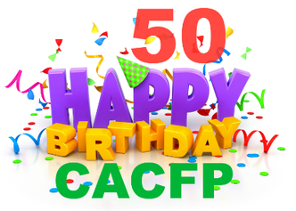



# It’s all about the CACFP’s 50th Birthday Celebration

The Child and Adult Care Food Program was born on May 8, 1968 as a pilot program. Let’s celebrate 50 years of CACFP and take the opportunity to educate the public about CACFP and your program.

**Celebrate and create awareness**

Educate representatives, parents and the community about how the CACFP helps child care

 Provider’s serve well balanced, nutritious meals,

 Promote proper nutrition for growing children,

 Ensure and promote the long-term health benefits of the CACFP

**Your child care program- information and logo goes here!**

**Take the Pledge to tell one person about the Child and Adult Care Program’s Birthday**

USDA's Child and Adult Care Food Program plays a vital role in improving the quality of child care and making it more affordable for many low-income families. Over four million children receive 2.2 billion nutritious meals and snacks through CACFP. The program also provides meals and snacks to 130,000 adults who receive care in nonresidential adult day care centers. CACFP reaches even further to provide meals to children residing in emergency shelters, and snacks and suppers to youths participating in eligible afterschool care programs.

**Celebrate and Applaud CACFP and Yourself**

► Celebrate with children and parents with a CACFP celebration with activity and a healthy snack

► Share a creditable CACFP celebration recipe with parents and social media using #CACFP50Birthday   
► Build your own USDA CACFP celebration mixing bowl recipe book with the children and parents

► Take pictures with signs like #CACFP50Birthday #CACFPWorks #CACFPChildCare and post on Facebook

► Share your CACFP birthday story with the media, social media too.

► Invite the press, your elected representative for a site visit during the celebration

► Have a CACFP Birthday USDA TryDay, Tuesday Celebration!

► Involve the parents and children in planning a day’s worth of CACFP birthday celebration meals and snacks

► Celebrate that “***CACFP is considered a quality indicator in childcare”***