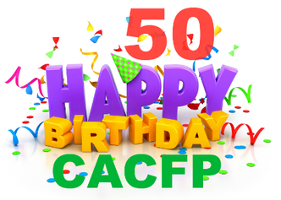



# It’s all about the CACFP’s 50th Birthday Celebration

The Child and Adult Care Food Program was born on May 8, 1968 as a pilot program. Let’s celebrate 50 years of CACFP and take the opportunity to educate the public about CACFP and your program.

**Celebrate and create awareness**

Educate representatives, parents and the community about how the CACFP helps child care

 Provider’s serve well balanced, nutritious meals,

 Promote proper nutrition for growing children,

 Ensure and promote the long-term health benefits of the CACFP

**Your child care program - information and logo goes here!**

**Take the Pledge to tell one person about the Child and Adult Care Program’s Birthday**

USDA's Child and Adult Care Food Program plays a vital role in improving the quality of child care and making it more affordable for many low-income families. Over four million children receive 2.2 billion nutritious meals and snacks through CACFP. The program also provides meals and snacks to 130,000 adults who receive care in nonresidential adult day care centers. CACFP reaches even further to provide meals to children residing in emergency shelters, and snacks and suppers to youths participating in eligible afterschool care programs. Tell them and Celebrate 50 CACFP years

**Celebrate CACFP’s 50the Birthday and Yourself**

► Make and send a birthday card signed by the children to your food program person, [examples](http://www.cacfpforum.com/birthday-cards.html)

► Celebrate with a #CACFP Fun/Run Walk with kids and parents and creditable snacks, [send us the pictures](mailto:cclark@cacfpforum.com?subject=Sending%20Birthday%20pictures)

► Share a healthy birthday cake creation with parents and social media using #CACFP50 and [webpage](http://www.cacfpforum.com/birthday-cakes.html)  
► Build your own USDA CACFP Birthday [mixing bowl](https://whatscooking.fns.usda.gov/cookbook) recipe book with the children and parents

► Take pictures with signs like #CACFP50 and post on social media

► Share your CACFP birthday story with the media, social media too. [Ideas and Tools](http://www.cacfpforum.com/materials.html)

► Invite the press, your elected representative for a site visit during the celebration, awareness leave behind

► Have a CACFP Birthday USDA [TryDay,](https://www.fns.usda.gov/tn/make-today-try-day-cacfp-postersticker-set) Tuesday Celebration!

► Have a CACFP Birthday Party and help the children decorate and create a healthy birthday cake and snacks

► Celebrate that “***CACFP is considered a quality indicator in childcare” and that you are a part of it***