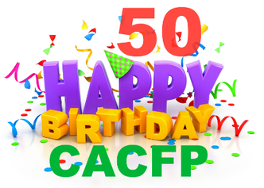



# It’s all about the CACFP’s 50th Birthday Celebration

The Child and Adult Care Food Program was born May 8, 1968 as a pilot program. Let’s celebrate 50 years of CACFP and take the opportunity to educate the public about CACFP and your program.

**Celebrate CACFP’s 50th Birthday and Create Awareness**

Educate representatives, parents and the community about how the CACFP helps child care

 Provider’s serve well balanced, nutritious meals,

 Promote proper nutrition for growing children,

 Ensure and promote the long-term health benefits of the CACFP

**Celebrate and Applaud CACFP and Yourself**

► Follow steps 1-4 on the Forum’s Birthday [Webpage](http://www.cacfpforum.com/happy-birthday-cacfp.html) (everything you need is there waiting for you)

► Sign the National CACFP Birthday Card

► Celebrate on visits with CACFP celebration materials for providers and/or children and/or parents  
► Share a creditable CACFP birthday celebration recipe with providers, they in turn can share with parents  
► Build a USDA CACFP celebration mixing bowl recipe book to share with the children, providers and parents

► Celebrate with a leave behind; bookmarks, stickers, a smile that tells people about CACFP and celebrates

► Take pictures with signs like #CACFP50 #CACFPWorks #CACFPChildCare #CACFPpays and post on Facebook

► Share your CACFP birthday story with the media. Invite the press, your representative for a site visit during the celebration.

Visit your representative and take an awareness leave behind

► Encourage providers to have a CACFP Birthday USDA Try Day, Tuesday Celebration!

► Involve the parents in a CACFP birthday celebration with recipes or informational handouts

► Celebrate that ***CACFP is considered a quality indicator in childcare”***

► Celebrate with CACFP staff and other CACFP Sponsors and state agencies

► More things to do on the Celebrate CACFP Birthday Page @ <http://www.cacfpforum.com/happy-birthday-cacfp.html>

**Take the Pledge to do one thing for the Child and Adult Care Program’s 50th Birthday**

Celebrate USDA's Child and Adult Care Food Program vital role in improving the quality of day care and making it more affordable for many low-income families. Over four million children receive 2.2 billion nutritious meals and snacks through CACFP. The program also provides meals and snacks to 130,000 adults who receive care in nonresidential adult day care centers. CACFP reaches even further to provide meals to children residing in emergency shelters, and snacks and suppers to youths participating in eligible afterschool care programs.

**Your Agency information and logo goes here!**